# CS 255 System Design Document Template

This template lays out all the different sections that you need to complete for Project Two. Each section has guidance to prompt your thinking. You will need to continually reference the interview transcript as you work to make sure that you are addressing your client’s needs. There is no required length for the final document. Instead the goal is to complete each section based on what your client’s needs are. Remove this note when you are finished, and replace all bracketed text with the relevant information.

## UML Diagrams

### UML Use Case Diagram

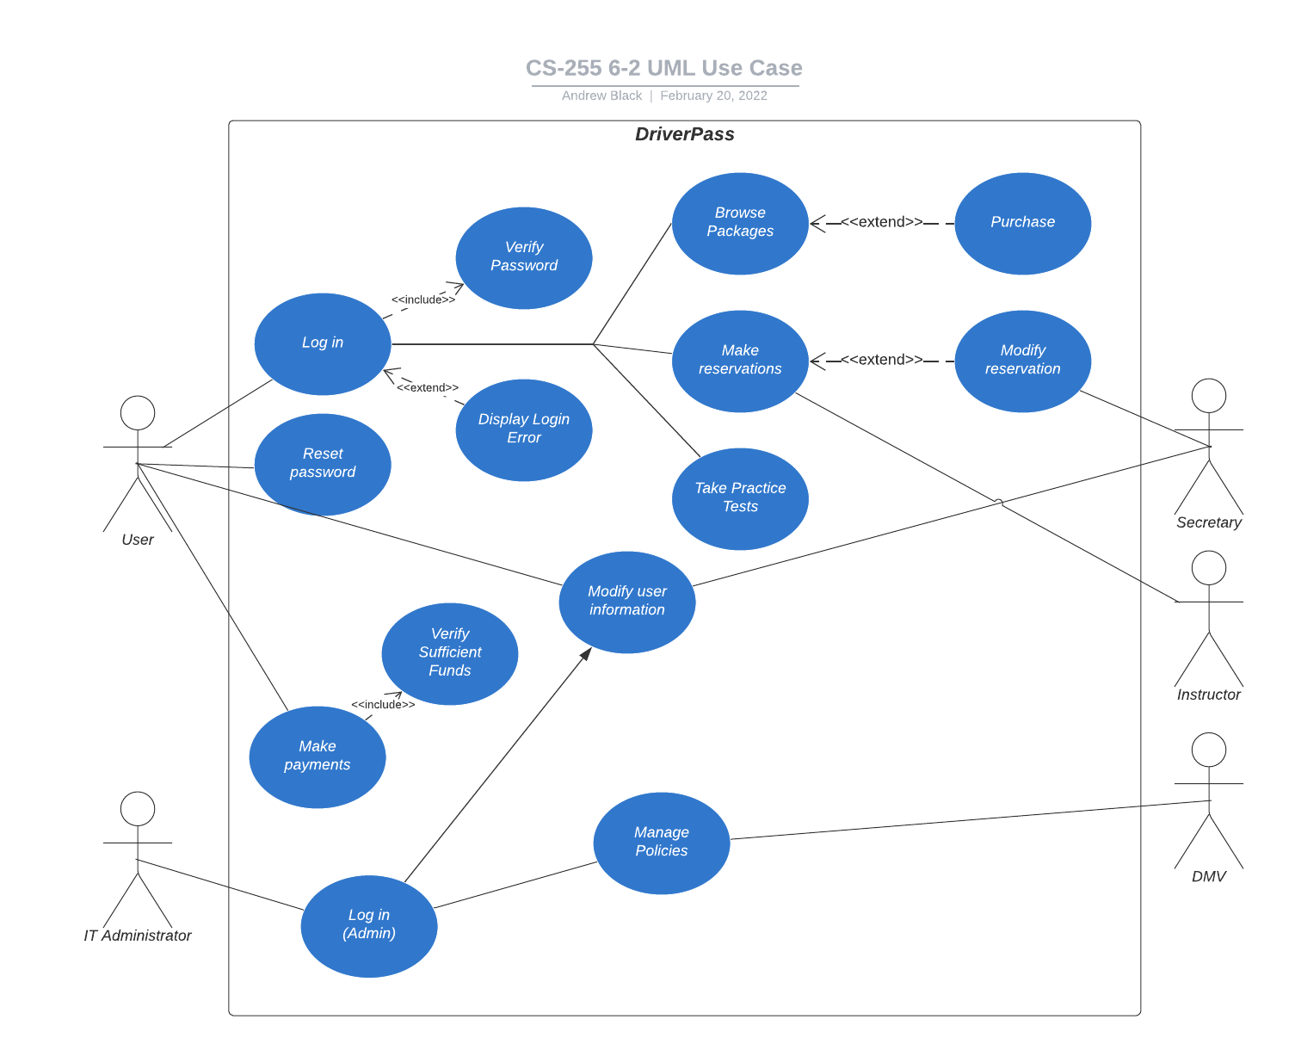

### UML Activity Diagrams

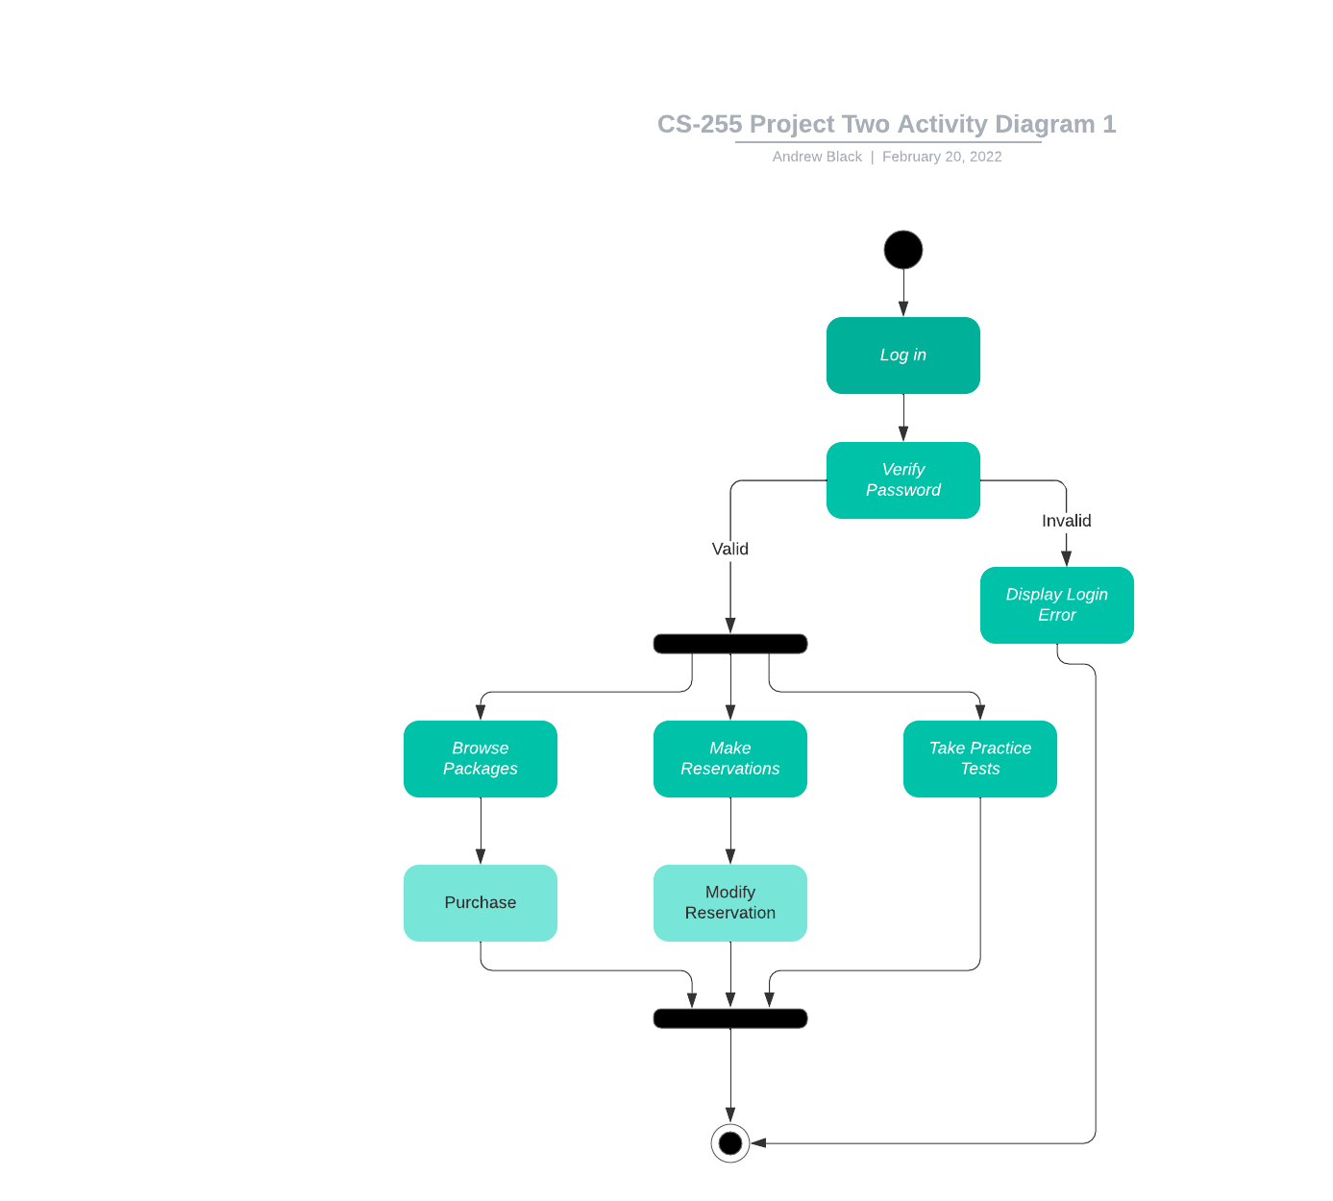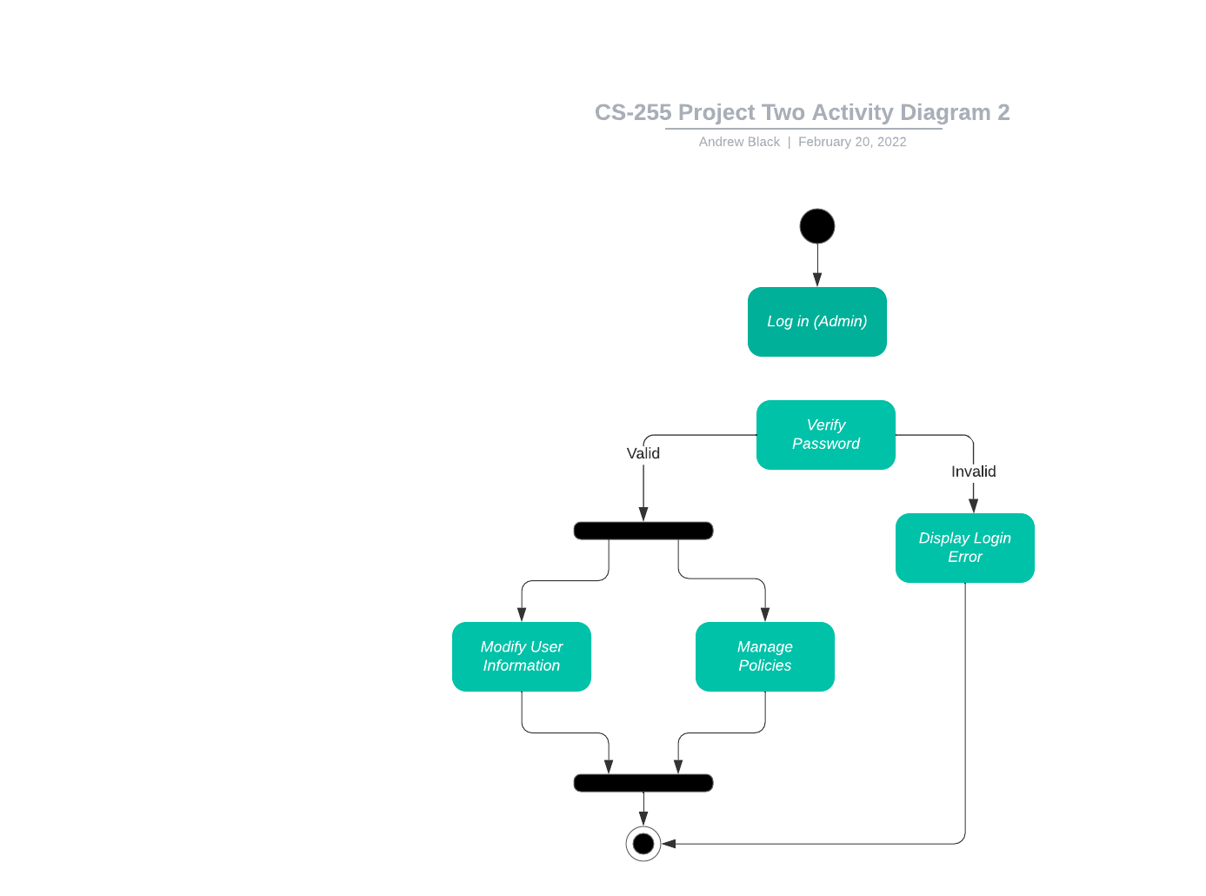

### UML Sequence Diagram

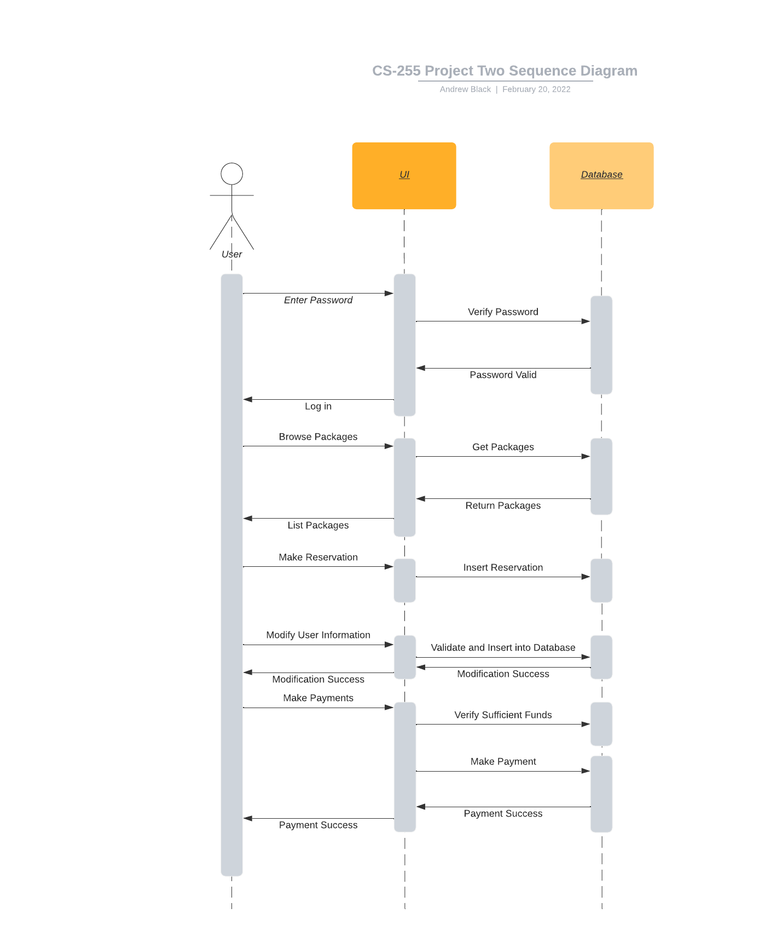

### UML Class Diagram

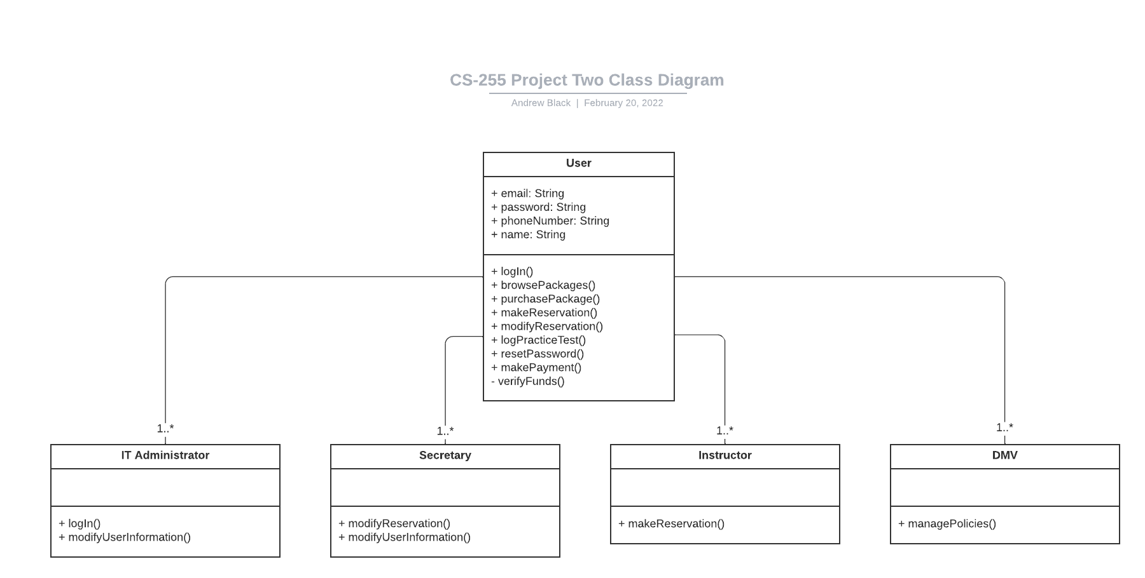

## Technical Requirements

*The system will be a web app developed for the cloud. It will run on a Linux server and allow for IT administrators to access the infrastructure managing it. All inbound and outbound connections to and from the server must use TLS v1.2 to ensure that all data is handled securely. Clients are required to use a web browser that supports HTTPS/1.2, which means all modern browsers. A system would need implemented to ensure that individuals are only allowed to access the parts of the system they are granted access to. For example: a user should not be able to manage the user information of other users, and the DMV should not be able to make reservations or pay bills for a user. The system should be supported from mobile, meaning anyone can access, manage, and download their data on the go.*